KARNATAK LAW SOCIETY’S

GOGTE INSTITUTE OF TECHNOLOGY

UDYAMBAG, BELAGAVI-590008

(An Autonomous Institution under Visvesvaraya Technological University, Belagavi)

**(APPROVED BY AICTE, NEW DELHI)**



*Course Activity report*

*on*

***Sentimental Analysis on Customer product review***

*Submitted in the partial fulfillment for the academic requirement of*

***5th Semester B.E.***

***in***

***Computer Science Engineering***

***Submitted by***

Atreay Kukanur

Ramesh Pawar

Om Shintre

Prem Hagargi

**GUIDE**

*Prof.Namita Bhat*

**2021 – 2022**

Karnataka Law Society’s

GOGTE INSTITUTE OF TECHNOLOGY

Udyambag Belagavi -590008

Karnataka, India.

**Department of Computer Science and Engineering**



**Certificate**

This is to certify that the Course seminar report work titled **“*Sentimental Analysis on Customer product review* ”** carried out by Atreay Kukanur, Ramesh Pawar, Om Shintre, Prem Hagargi bearing **USNs:** 2GI19CS028,2GI19CS110, 2GI19CS087, 2GI19CS100 is submittedin partial fulfilment of the requirements for 5th semester B.E. in **Computer Science and Engineering,** Visvesvaraya Technological University, Belagavi. It is certified that all corrections/ suggestions indicated have been incorporated in the report. The course project report has been approved as it satisfies the academic requirements prescribed for the said degree.

Date: Signature of Guide

Place: Belagavi Guide Name

**Prof.Namita Bhat**

KLS Gogte Institute Technology, Belagavi

Name of the Examiners Signature of the Examiners

1.___________________ 1.____________________

2.____________________ 2.____________________

**Title: *Sentimental Analysis on Customer product review***

**Team Members Details:**

|  |  |  |
| --- | --- | --- |
| **S. No.** | **USN** | **Student Name** |
| 1 | 2GI19CS028 | Atreay Kukanur |
| 2 | 2GI19CS110 | Ramesh Pawar |
| 3 | 2GI19CS087 | Om Shintre |
| 4 | 2GI19CS100 | Prem Hagargi |

**Marks Allocation:**

|  |  |  |  |  |  |  |
| --- | --- | --- | --- | --- | --- | --- |
|  | **Batch No.: 13** | | | | | |
| 1. | Seminar Title: | Marks Range | **USN** | | | |
| **2GI19CS028** | **2GI9CS110** | **2GI19CS087** | **2GI19CS100** |
| 2. | Abstract (PO2) | 0-2 |  |  |  |  |
| 3. | Application of the topic to the course (PO2) | 0-3 |  |  |  |  |
| 4. | Literature survey and its findings (PO2) | 0-4 |  |  |  |  |
| 5. | Methodology, Results and Conclusion  (PO1, PO3, PO4) | 0-6 |  |  |  |  |
| 6. | Report and Oral presentation skill (PO9, PO10) | 0-5 |  |  |  |  |
|  | Total | 20 |  |  |  |  |

**Signature of Staff:**

**Introduction:**

Sentiment analysis is the automated process of determining whether a text expresses a positive, negative, or neutral opinion about a product or topic.By using sentiment analysis, companies don’t have to spend endless hours tagging customer data such as survey responses, reviews, support tickets, and social media comments. Sentiment analysis helps companies monitor their brand reputation on social media, gain insights from customer feedback, and much more!

Sentiment Analysis is the domain of understanding these emotions with software, and it’s a must-understand for developers and business leaders in a modern workplace. Sentiment analysis also does Visualization by using several libraries in python like – matplotlib, seaborn etc.

**Problem statement for that the project:**

Sentiment Analysis aims to determine the overall intention of a written text which can be of admiration or criticism type. This can be achieved by analysing the customer dataset and its details and then represent the dataset using charts. Sentiment Analysis can be implemented using python language and google collab using appropriate attributes and their name.

**Objectives of Defined Problem statement:**

* ***Sentiment analysis for brand monitoring:***

One of the most well documented uses of sentiment analysis is to get a full 360 view of how your brand, product, or company is viewed by your customers and stakeholders. Widely available media, like product reviews and social, can reveal key insights about what your business is doing right or wrong. Companies can also use sentiment analysis to measure the impact of a new product, ad campaign, or consumer’s response to recent company news on social media. Private companies like Unamo offer this as a service

* ***Sentimental analysis for customer service:***

Customer service agents often use sentiment or intent analysis to automatically sort incoming user email into “urgent” or “not urgent” buckets based on the sentiment of the email, proactively identifying frustrated users. The agent then directs their time toward resolving the users with the most urgent needs first. As customer service becomes more and more automated through machine learning, understanding the sentiment and intent of a given case becomes increasingly important.

* ***Sentimental analysis for market research:***

Sentiment analysis is used in business intelligence to understand the subjective reasons why consumers are or are not responding to something (e.x. why are consumers buying a product? What do they think of the user experience? Did customer service support meet their expectations?). Sentiment analysis can also be used in the areas of political science, sociology, and psychology to analyse trends, ideological bias, opinions, gauge reactions, etc

* Predict price fluctuations based on public interest

**Methodology:**

* We have taken a Customer Dataset to visualize the data.
* We have used Google Collab to implement our project.
* We have python programming language to retrieve the dataset.
* We have used matplotlib and seaborn libraries to implement Sentimental analysis.
* We have used the graphs, plot, Bar charts for better visualization of Sentimental data.

**Implementation Details:**

***Libraries Used:***

* ***Numpy:***

NumPy is the fundamental package for scientific computing in Python. It is a Python library that provides a multidimensional array object, various derived objects (such as masked arrays and matrices), and an assortment of routines for fast operations on arrays, including mathematical, logical, shape manipulation, sorting, selecting, I/O, discrete Fourier transforms, basic linear algebra, basic statistical operations, random simulation and much more.

* ***Pandas:***

Pandas is an open-source, BSD-licensed Python library providing high-performance, easy-to-use data structures and data analysis tools for the Python programming language. Python with Pandas is used in a wide range of fields including academic and commercial domains including finance, economics, Statistics, analytics, etc

* ***Matplotlib:***

Matplotlib is an amazing visualization library in Python for 2D plots of arrays. Matplotlib is a multi-platform data visualization library built on NumPy arrays and designed to work with the broader SciPy stack. It was introduced by John Hunter in the year 2002.

* One of the greatest benefits of visualization is that it allows us visual access to huge amounts of data in easily digestible visuals. Matplotlib consists of several plots like line, bar, scatter, histogram etc.severascatterhistogram etc.
* **Natural Language Toolkit(nltk):**

The **Natural Language Toolkit**, or more commonly **NLTK**, is a suite of libraries and programs for symbolic and statistical natural language processing (NLP) for English written in the Python programming language. It was developed by Steven Bird and Edward Loper in the Department of Computer and Information Science at the University of Pennsylvania NLTK includes graphical demonstrations and sample data. It is accompanied by a book that explains the underlying concepts behind the language processing tasks supported by the toolkit, plus a cookbook.

* **Word Cloud:**

Word Cloud is a data visualization technique used for representing text data in which the size of each word indicates its frequency or importance. Significant textual data points can be highlighted using a word cloud. Word clouds are widely used for analysing data from social network websites.

* **Seaborn:**

Seaborn is a library for making statistical graphics in Python. It builds on top of [matplotlib](https://matplotlib.org/) and integrates closely with [pandas](https://pandas.pydata.org/) data structures. Seaborn helps you explore and understand your data. Its plotting functions operate on dataframes and arrays containing whole datasets and internally perform the necessary semantic mapping and statistical aggregation to produce informative plots. Its dataset-oriented, declarative API lets you focus on what the different elements of your plots mean, rather than on the details of how to draw them.

* **vanderSentiment:**

VADER stands for **V**alence **A**ware **D**ictionary and s**E**ntiment **R**easoner, which is a lexicon and rule-based sentiment analysis tool that is specifically attuned to sentiments expressed in social media, and works well on text from other domains.

**Working model of the final solution:**

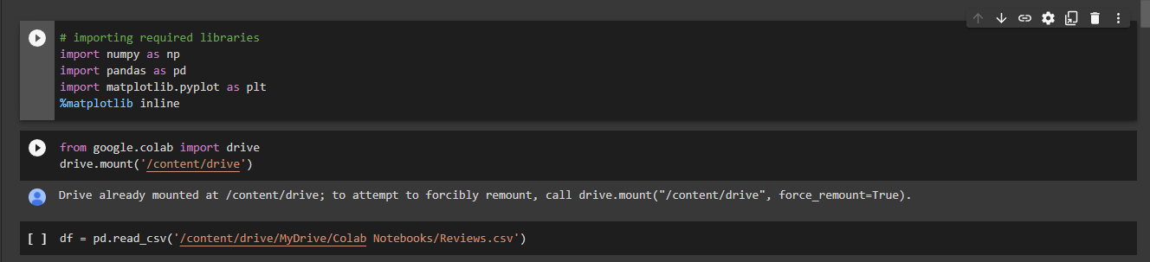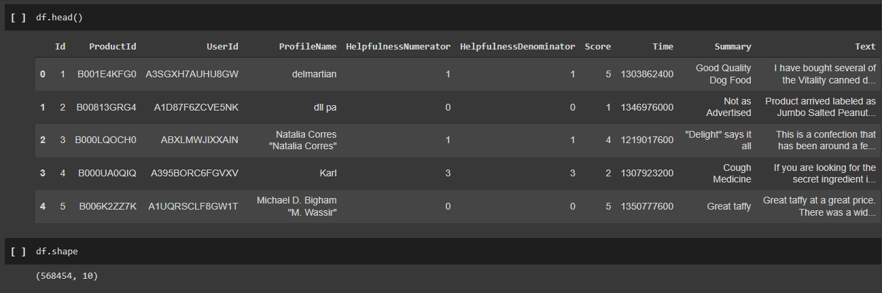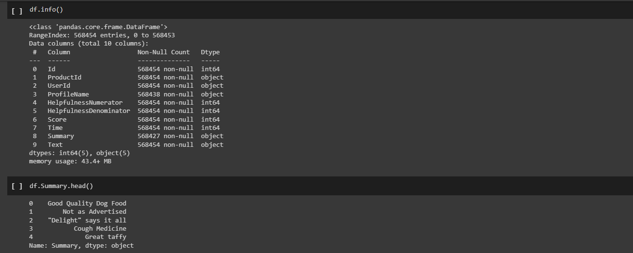

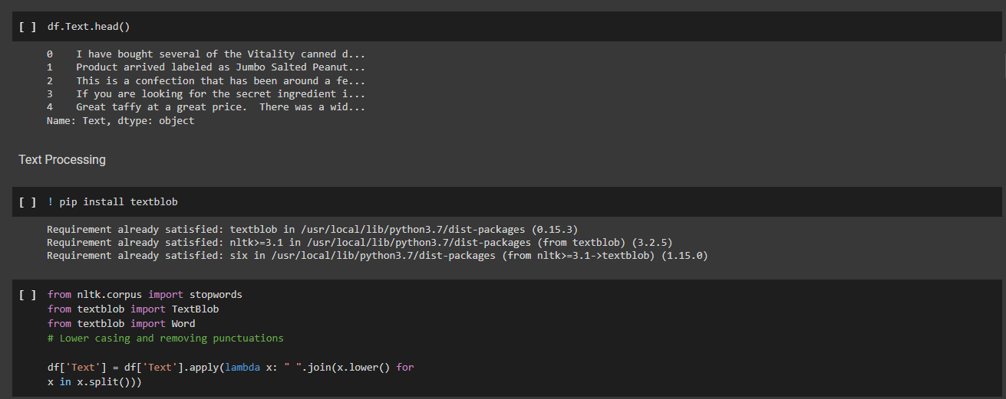

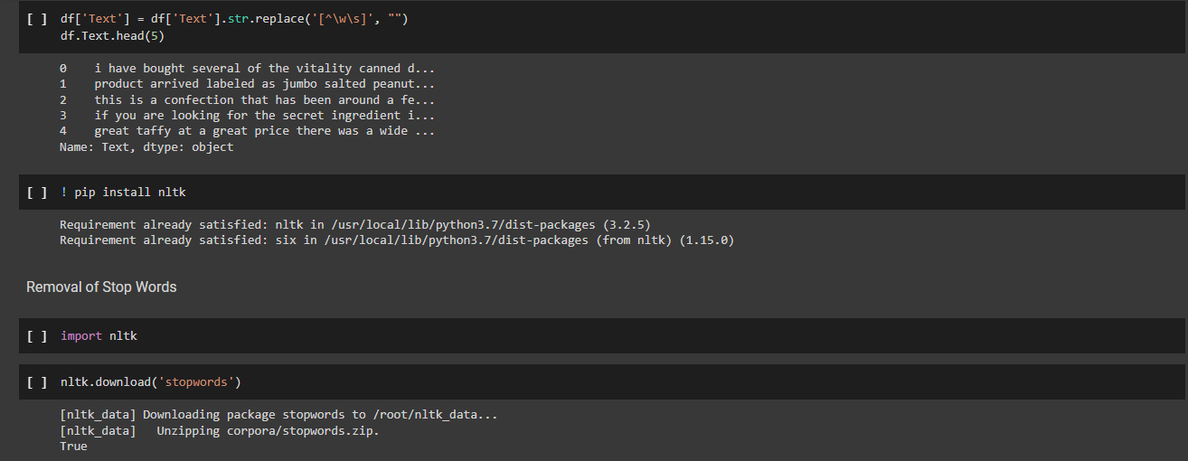 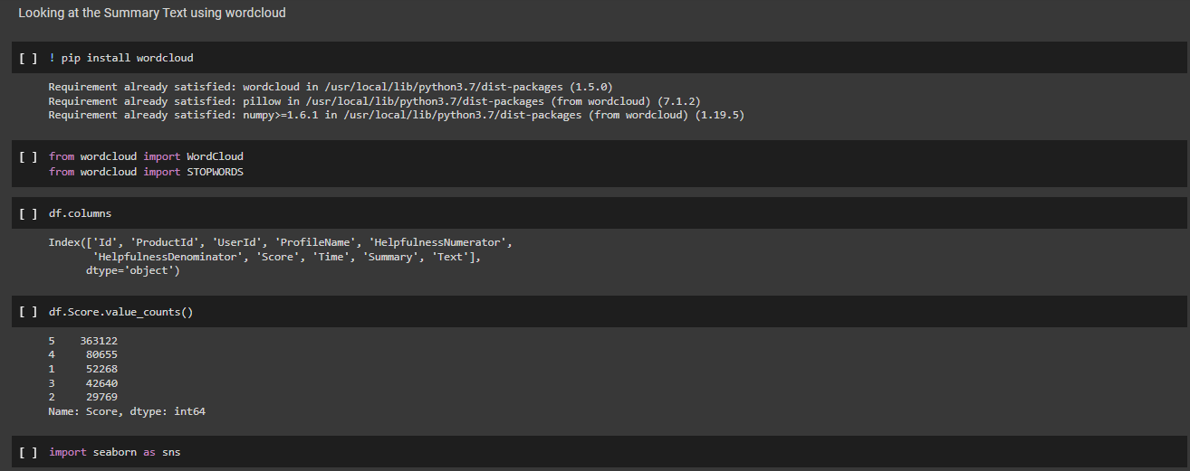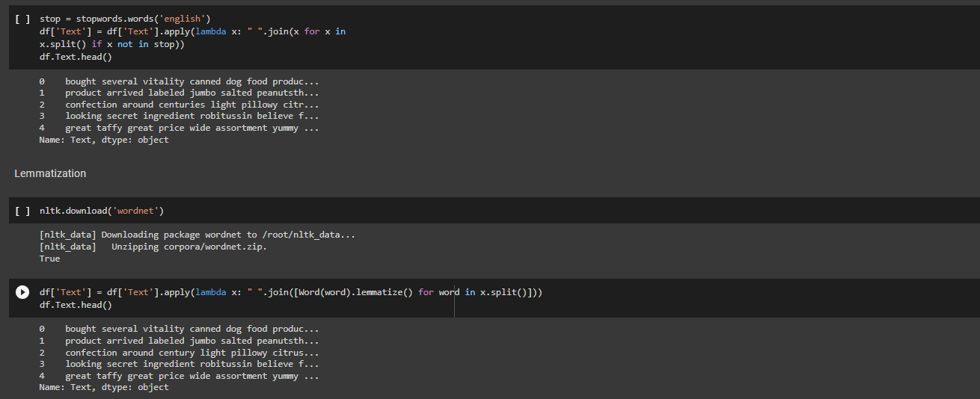 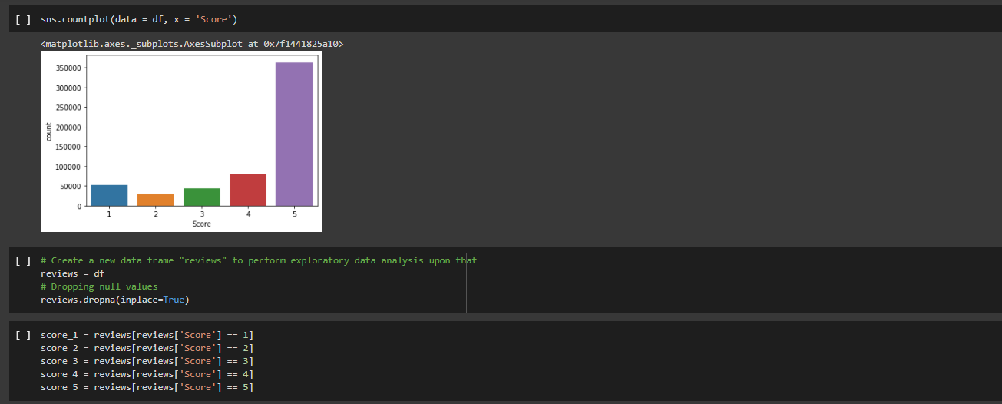

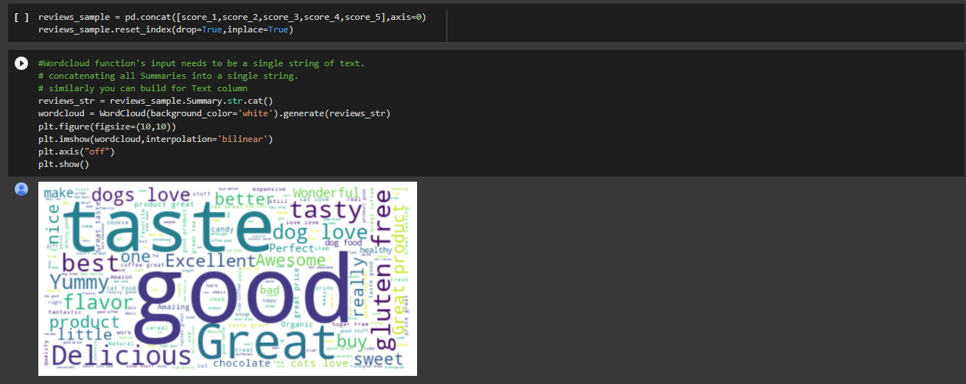 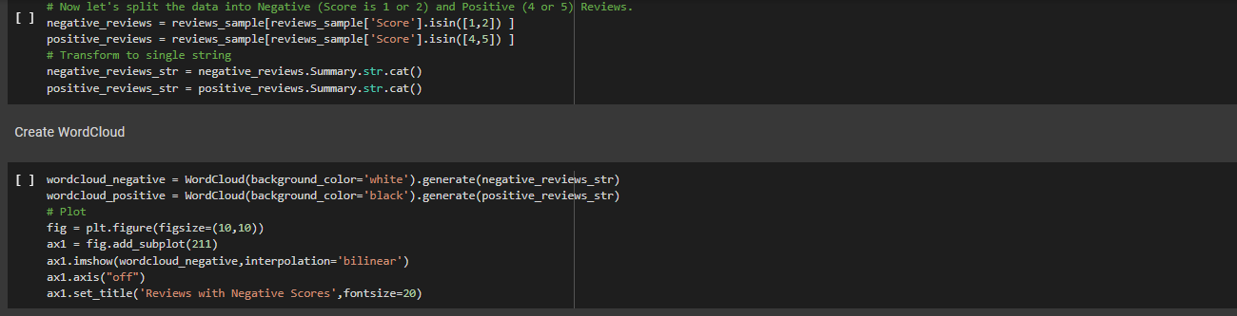 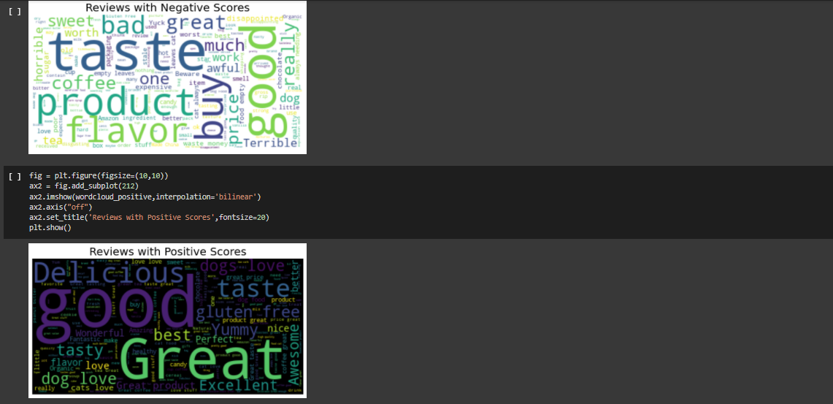 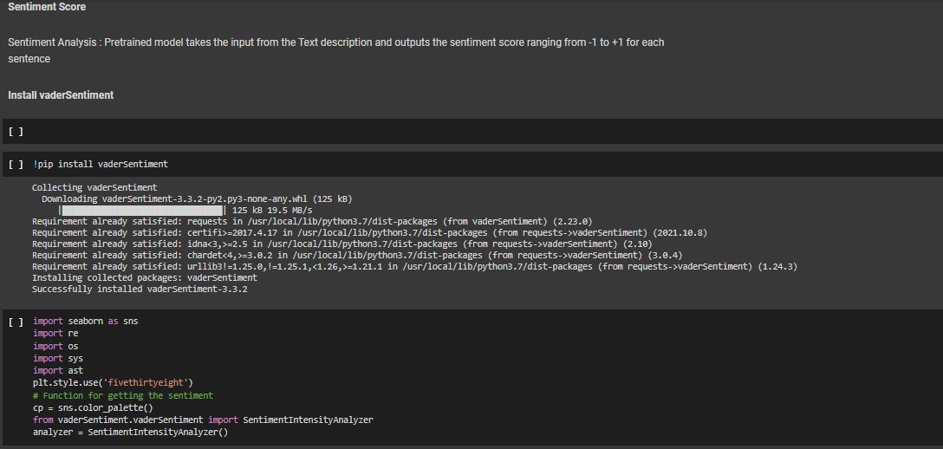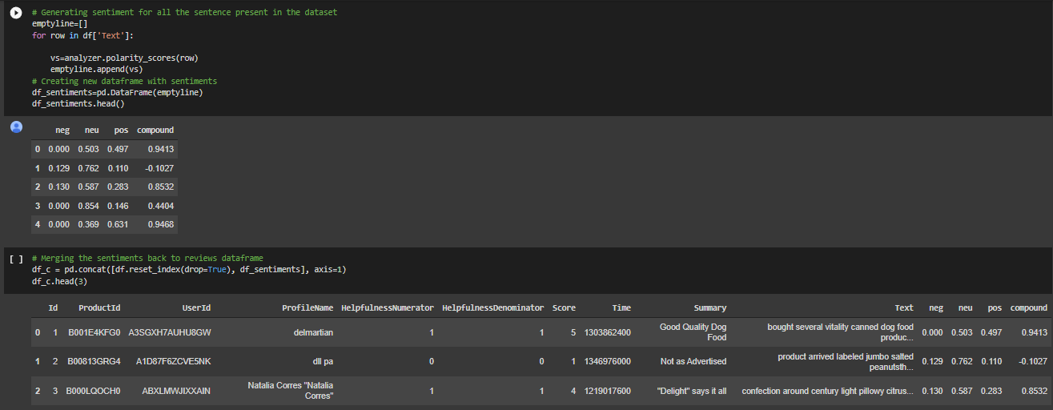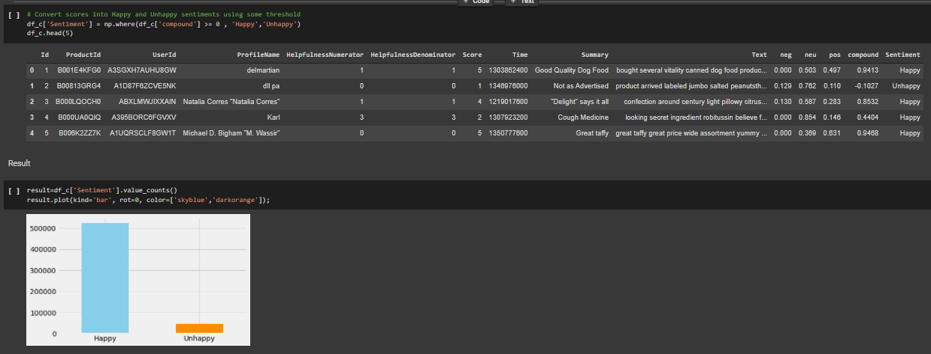

**Conclusion:**

From the demonstration it is clear that the sentimental analysis of customer review dataset correctly visualized and the results are appropriate. Sentiment analysis is important as this is a field of study that analyses people’s sentiments, attitudes, or emotions towards certain entities.

**References:**

1. Jiawei Han, Micheline Kamber , Jian Pei: Data Mining - Concepts and Techniques , 3rd Edition, Morgan Kaufmann Publishers, 2011.
2. Pang-Ning Tan, Michael Steinbach, Vipin Kumar: Introduction to Data Mining, Addison-Wesley, 2007.
3. G. K. Gupta: Introduction to Data Mining with Case Studies, 3rd Edition, PHI, New Delhi, 2014.